Jay M. Johnson, LLC

Accounting & Tax Advisory Services

Tax Advisory & Preparation

Assurance & Accounting

Business Advisory

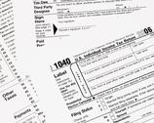

Contact Information:

Phone: (907) 220-9970

Email: jayjohnson@ketchikancpa.com

